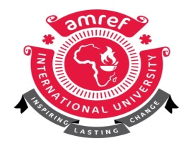

AMREF INTERNATIONAL UNIVERSITY
SCHOOL OF PUBLIC HEALTH
DEPARTMENT OF HEALTH SYSTEMS MANAGEMENT AND DEVELOPMENT
MASTERS IN BIOETHICS
END OF FIRST SEMESTER EXAMINATION SEPTEMBER - DECEMBER 2023
MBE 715 FOUNDATIONS OF HEALTH SYSTEMS
Date :
TIME : Three Hours Start-----------------------End…………………

INSTRUCTIONS TO CANDIDATES

- This exam is out of 70 marks
- Section-A is compulsory with a Total of 30 Marks
- Answer any TWO (2) questions in Section B
Read carefully the additional instructions preceding each section.

SECTION A
SHORT ANSWER QUESTIONS (30 MARKS)
Question 1
- State any three reasons why the health system actually starts from the household level. (3 marks)
- Outline any three major objectives of a health system using examples from Kenya. (6 marks)
- List the building blocks of a health system. (6 marks)
- Identify any five key principles for successful health systems integration. (5 marks)
- Outline any two reasons why the healthcare organisations are open systems. (4 marks)
- Define the following healthcare models
- The Beveridge Model (2 marks)
- The Bismarck Model (2 marks)
- The National Health Insurance Model (2 marks)

SECTION B
LONG ANSWER QUESTIONS: ANSWER ANY TWO (2) QUESTIONS (40 Marks)
Question 2
Explain any five reasons why primary health care and public health are the foundations of a successful health system. (20 marks)

Question 3
Examine the key functions of the health system giving examples from Kenya. (20 marks)

Question 4
Appraise the Kenya Health System and make relevant recommendations considering the building blocks of the health system as per the World Health Organization (WHO). (20 marks)

